Asssignment-2

|  |  |  |
| --- | --- | --- |
|  | **School of Engineering & Technology** | |
| **Department: CSE** | **Session:** Odd |
| **Programmer**: B. Tech CSE (Specialization in AI & MLs) | **Semester:** 1 |
| **Course Code:** ETCCCP105 | **Name of student-**  **PAWAN KUMAR SINGH (2501730252)** |
| **Course Name:** Computer Science Fundamentals & Career Pathways | **Faculty: Dr. Ravinder Beniwal** |

**PAWAN KUMAR SINGH**

**2501730252**

**Shell Command Implementation and Documentation**

**a) File Navigation**

**1. ls (List Directory Contents)**

* **Syntax:** ls [options] [file/directory]
* **Description:** The ls command lists the contents of a directory. Without any arguments, it lists the contents of the current directory.
* **When and Why it's used:** It's a fundamental command used constantly to see what files and subdirectories are present in a given location. This helps you understand the structure of your file system and locate specific items.

$ ls

Desktop Documents Downloads Music Pictures Public Templates Videos

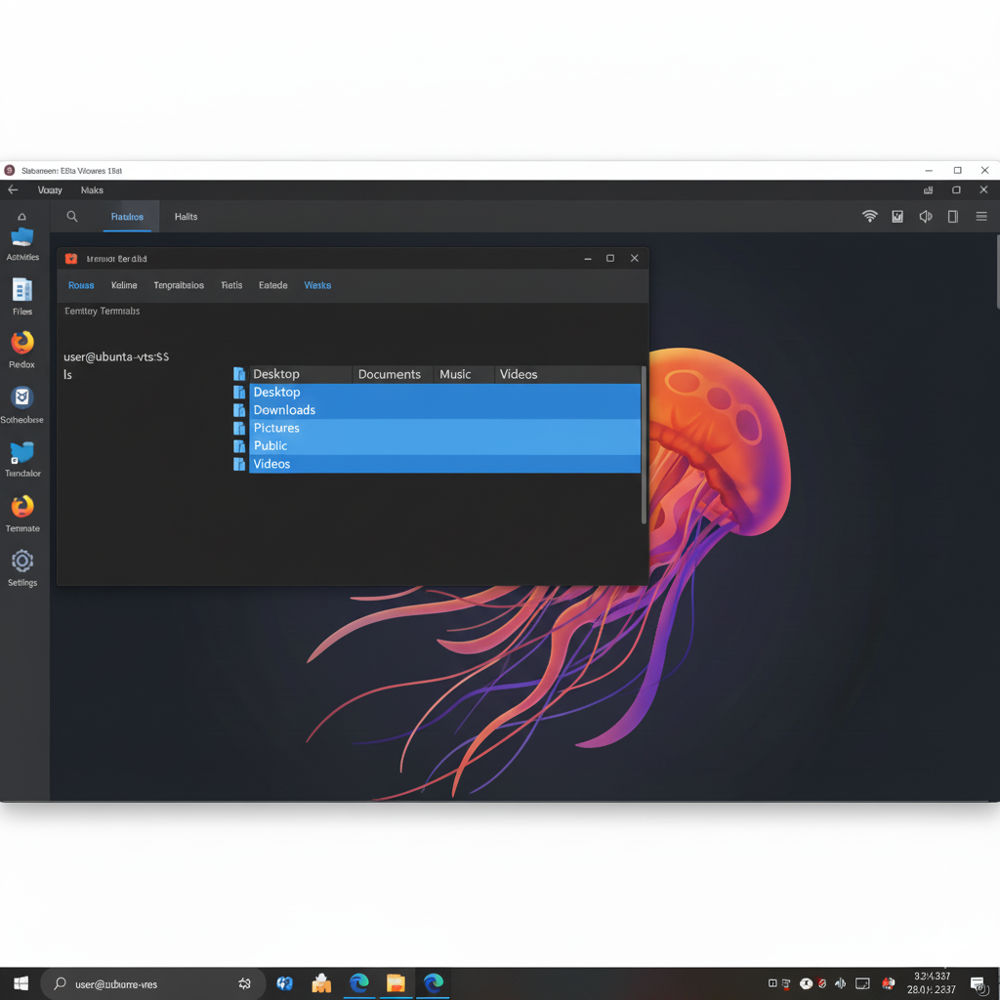

**2. cd (Change Directory)**

* **Syntax:** cd [directory]
* **Description:** The cd command changes the current working directory.
* **When and Why it's used:** It's essential for navigating through the file system. You use it to move into a subdirectory, go back to a parent directory, or jump directly to a specific path.

$ p w d

/home/user

$ cd Documents

$ pwd

/home/user/Documents

$ cd ..

$ pwd

/home/user

$ cd ~

$ pwd

/home/user

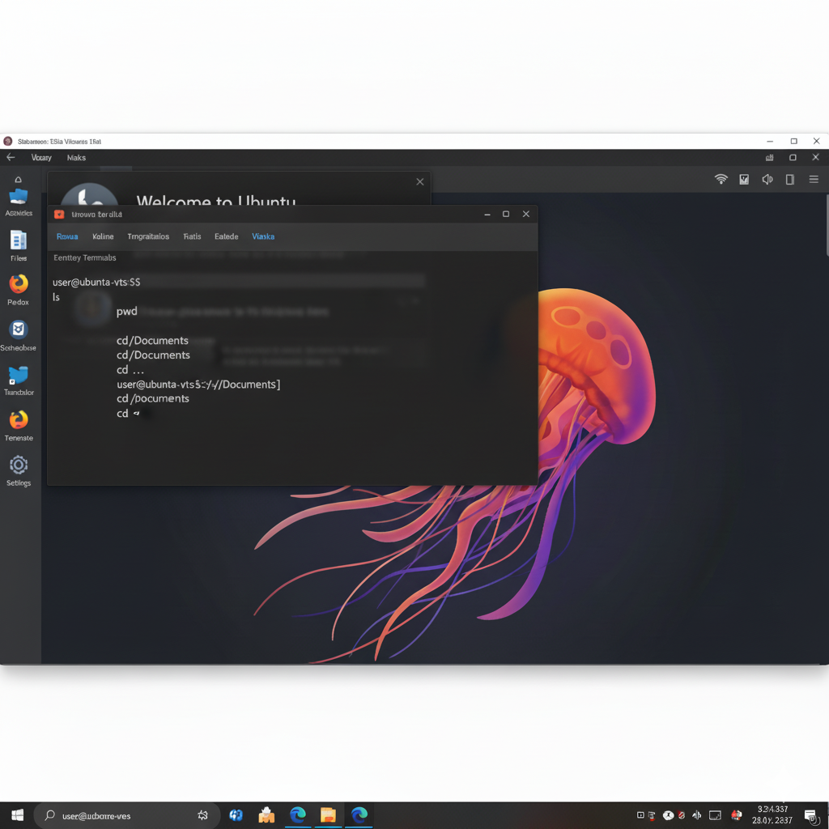

*Special `cd` uses:*

* `cd ..`: Go up one directory level.

* `cd`: Go to your home directory.

* `cd -`: Go back to the previous directory.

**3. pwd (Print Working Directory)**

* **Syntax:** pwd
* **Description:** The pwd command prints the full pathname of the current working directory.
* **When and Why it's used:** It's used to quickly determine your current location within the file system hierarchy. This is particularly useful when you've navigated several levels deep or are working with complex directory structures and need to confirm where you are.

$ pwd

/home/user/Documents/project

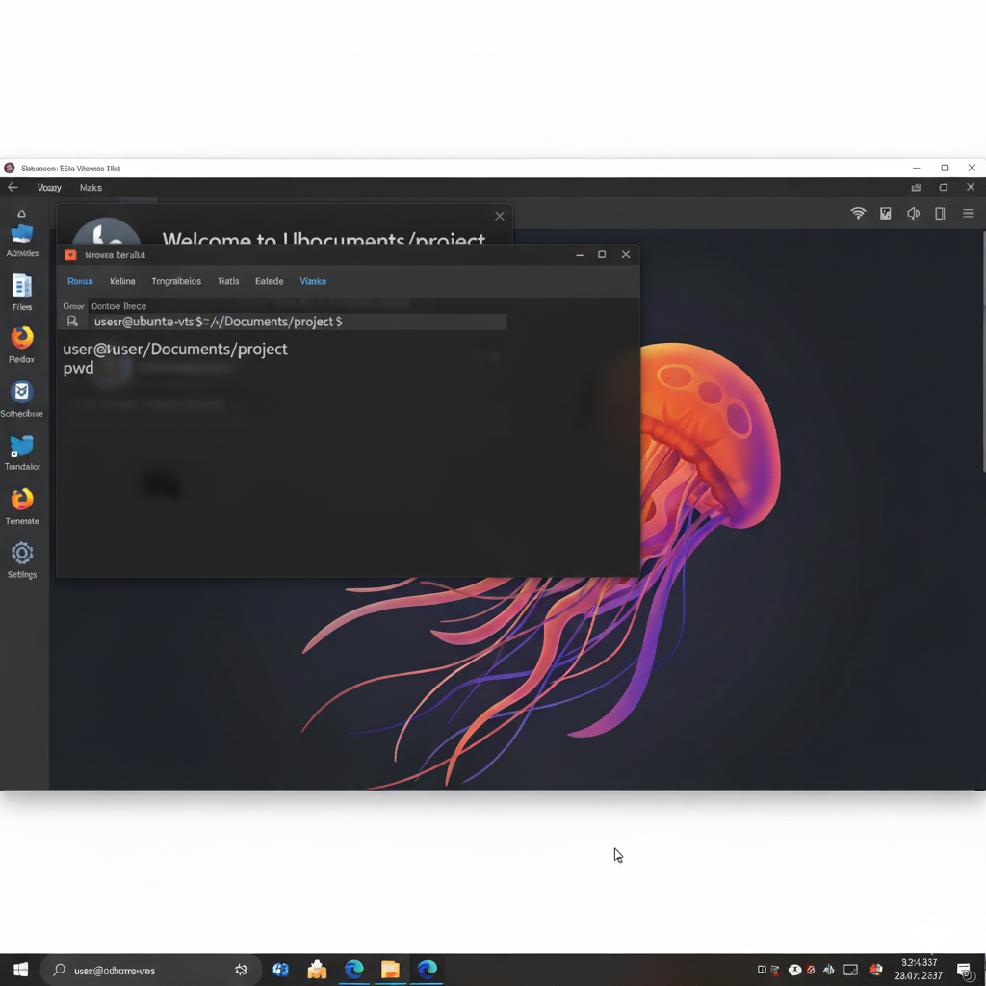

**4. tree (List Contents of Directories in a Tree-like Format)**

* **Syntax:** tree [options] [directory]
* **Description:** The tree command recursively lists the contents of directories in a tree-like format, showing the directory structure.
* **When and Why it's used:** It's incredibly useful for getting a quick, visual overview of a directory's hierarchy and its subdirectories and files. This helps in understanding the project structure or locating files without navigating through each directory manually. You might need to install it first (sudo apt install tree).
* **Sample Output (with screenshot):**

codeBash

$ tree project_alpha

project_alpha

├── docs

│ └── README.md

├── src

│ ├── main.py

│ └── utils.py

└── tests

└── test_main.py

3 directories, 4 files

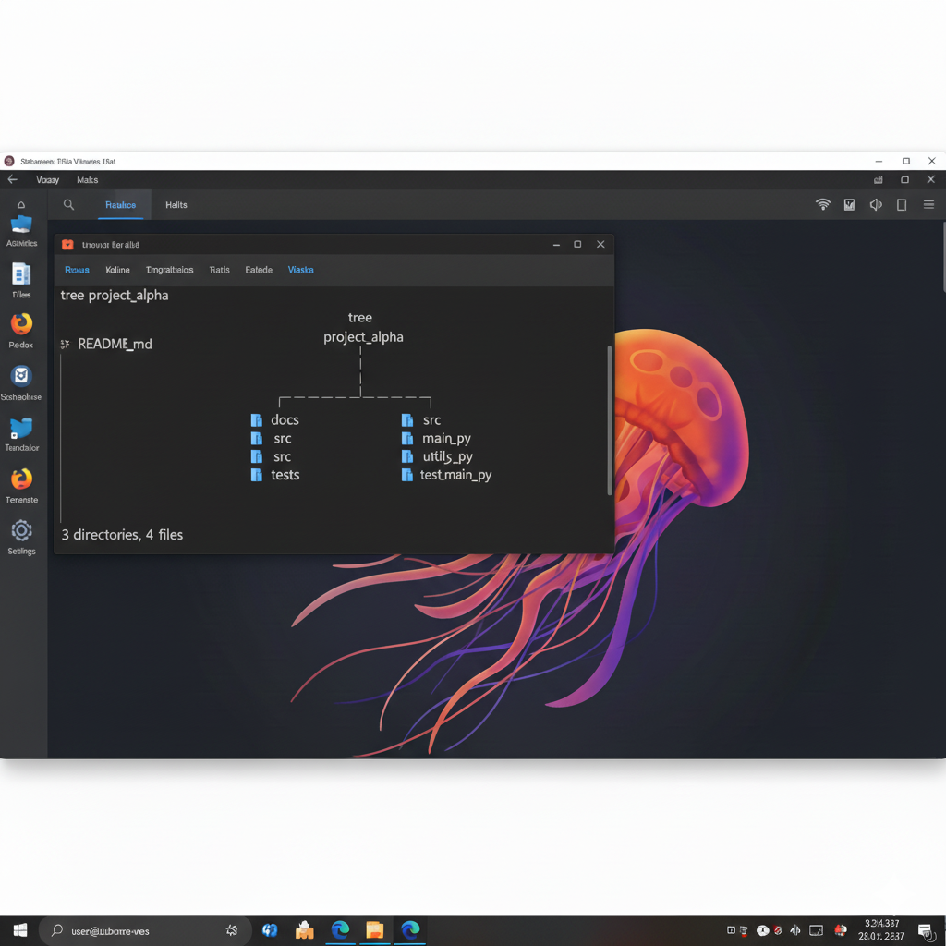

**b) File and Directory Management**

**5. mkdir (Make Directories)**

* **Syntax:** mkdir [options] directory_name(s)
* **Description:** The mkdir command creates new directories (folders).
* **When and Why it's used:** It's used to organize your files by creating a structured hierarchy. You'll use it every time you need to set up a new project, sort documents, or establish a new area for data.

codeBash

$ ls

Documents Downloads

$ mkdir new_project

$ mkdir -p personal/notes/work

$ ls

Documents Downloads new_project personal

$ tree personal

personal

└── notes

└── work

2 directories, 0 files

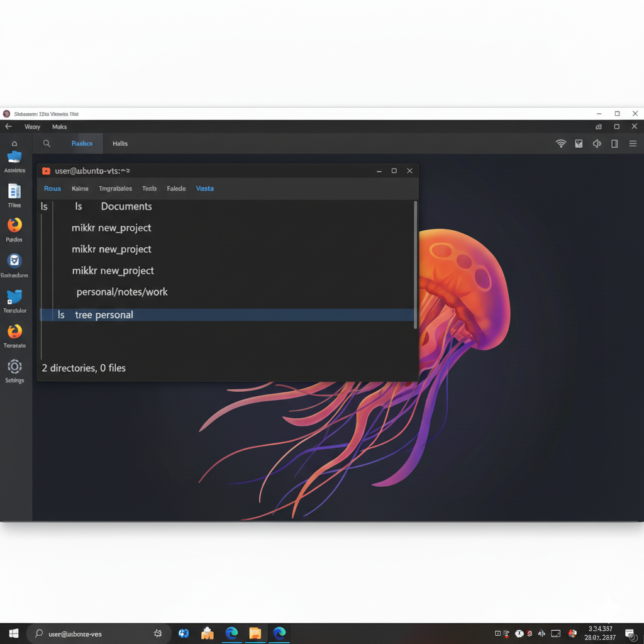

*Common options:*

* `mkdir -p`: Creates parent directories as needed. If `personal/notes` didn't exist, `-p` would create both `personal` and `notes` when creating `personal/notes/work`.

**6. touch (Change File Timestamps / Create Empty Files)**

* **Syntax:** touch [options] filename(s)
* **Description:** The touch command updates the access and modification times of files. If the file does not exist, touch creates an empty file with that name.
* **When and Why it's used:** It's frequently used to create new, empty files (e.g., for placeholders, script files, or log files before data is written). It can also be used to simply update a file's timestamp without changing its content, which can be useful in build systems or for marking a file as "recently modified."
* **Sample Output (with screenshot):**

code Bash

$ ls

new project personal

$ touch new_file.txt my_script.sh

$ ls -l

total 8

drwxrwxr-x 2 user user 4096 Apr 23 10:00 new_project

-rw-rw-r-- 1 user user 0 Apr 23 10:05 my_script.sh

-rw-rw-r-- 1 user user 0 Apr 23 10:05 new_file.txt

drwxrwxr-x 3 user user 4096 Apr 23 10:00 personal

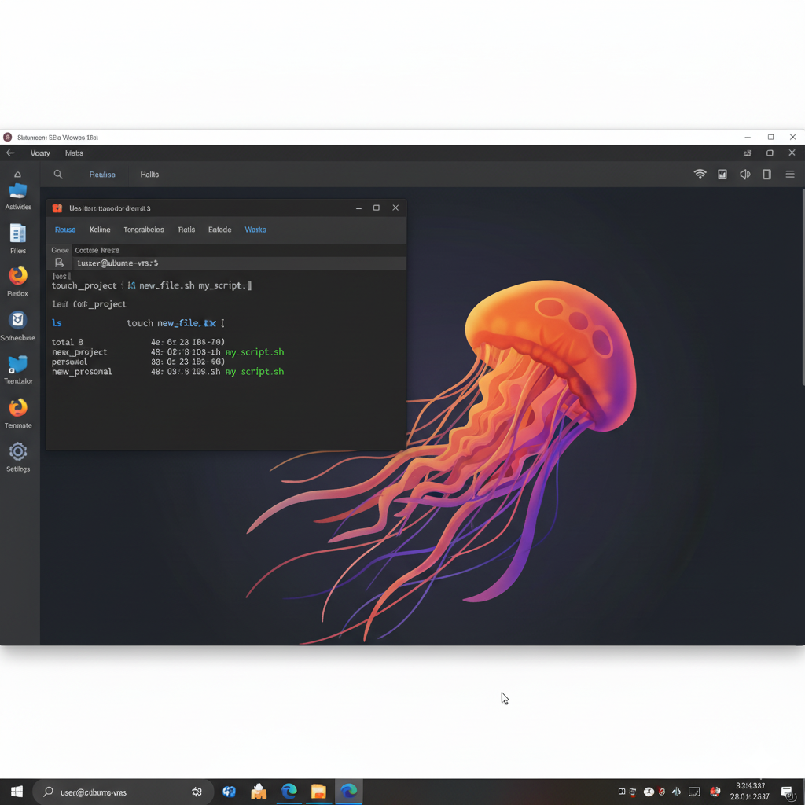

.

**7. cp (Copy Files and Directories)**

* **Syntax:** cp [options] source destination
* **Description:** The cp command copies files and directories from one location to another.
* **When and Why it's used:** It's used for making duplicates of files or folders. This is crucial for backups, moving data without losing the original, or preparing files for editing while keeping an untouched version.

$ ls

my_script.sh new_file.txt new project personal

$ cp new_file.txt backup_file.txt

$ cp -r new project/ backups/

$ ls

backup_file.txt backups my_script.sh new_file.txt new project personal

$ ls backups

new project

